PHYSICS SS3 FIRST TERM

PHYSICS SS3

1. Revision/Energy/Electromagnetic waves/Electromagnetic spectrum/uses
2. Gravitational field and law/gravitational potential/escape velocity
3. Electric field/Coulombs law/Electric field intensity/Electric potential/capacitor and capacitance/arrangement and application
4. Current electricity/pry and sec cells/Daniel , Leclanche, Lead-acid accumulator/Alkaline-Cadium cell
5. Electrolysis/Electrical Conduction Through Liquids and gases
6. Electric measurement-Resistivity, conductivity, conversion of galvanometer to Ammeter and Voltmeter, potentiometer, wheatstone bridge, meter bridge
7. Magnetic field: magnetic/non-magnetic material, temporary and permanent magnets, magnetization, demagnetization, magnetic flux and earth magnetic field
8. Magnetic field around current carrying conductor, circular conductor, solenoid, Application – electromagnet, uses-electric bells, telephone earpiece
9. Electromagnetic field – Fleming left hand rule, Application- DC motors, moving coil galvanometer
10. Electromagnetic induction – induced current, laws of electromagnetic induction, induction coil, A/C and Generator, transformers and power distribution, Eddy current
11. Revision
12. Examination

WEEK 1: ENERGY AND SOCIETY /ELECTROMAGNETIC WAVES

REVISION: Definition of energy, types and energy transformation and the law of conservation of energy.

**SOURCES OF ENERGY**

1. Solar energy
2. Fossil fuel (petroleum and natural gas)
3. Wind energy
4. Hydroelectric energy
5. Geothermal energy
6. Tidal and ocean
7. Biomass

**RENEWABLE AND NON-RENEWABLE**

*Renewable energy resources* are those that can be replenished/replaced as they are used up. Examples include solar, wind, biomass, tidal, biofuel

*Non-renewable energy resources* are those that cannot be replenished when they are used up. Examples nuclear energy (from radioactive substance), coal, wood, fossil fuel.

**USES OF ENERGY**

1. Transportation
2. Electricity supply to homes and industries.
3. For heating or cooling of homes
4. Information technology
5. Waste collection and recycling
6. Communication.
7. For operating domestic equipment eg freezer, grinding machines, etc.

**ENVIRONMENTAL IMPACT OF ENERGY USE**

The use of energy for various purposes have a great effect on the environment.

1. Acid rain
2. Greenhouse effect:
3. Global warming
4. Oil spillage

***ENERGY CRISIS***

Due to population growth, there is an enormous demand on energy. Supply is far less than demand. Energy crisis can occur due to shortage or increasing demand. The following factors can cause energy crisis:

1. Power outages
2. Industrial action by unions
3. Political decision
4. Bottlenecks at refineries
5. Vandalisation of pipelines
6. Monopoly manipulation of market.

***ASSIGNMENT: Define biomass and biofuel (ii) briefly explain how biomass are produced (iii) List three materials for making/producing biomass***

**ELECTROMAGNETIC WAVES (DEFINITION)**

These are waves that do not require a material medium for their propagation. They are formed from the vibrations of electric (E) and magnetic (M) fields.

# **The Electromagnetic Spectrum**

Electromagnetic waves exist with an enormous range of frequencies, from values less than 104 Hz to greater than 1022 Hz. The collection of all these waves is called *the electromagnetic spectrum*.

In increasing wavelength viz: Gamma ray, X-ray, Ultra-violet ray, visible light, Infra-red, microwave, radio wave.

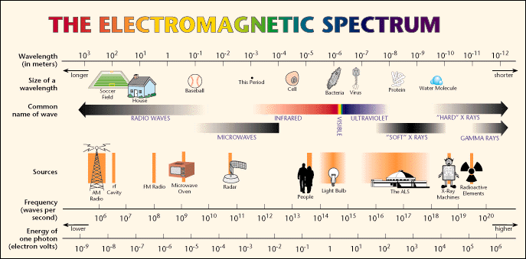

|  |  |  |
| --- | --- | --- |
| Type of Wave | Frequency Range (Hz) | Wavelength Range |
| Radio waves | 104 - 1012 | 104 – 10-4 m |
| Infra red | 1012 - 1014 | 10-4 – 10-6 |
| Visible |  | 700 – 400 nm |
| Ultra-violet | 1014 - 1017 | 10-7 – 10-8 m |
| X-rays | 1017 - 1020 | 10-8 – 10-12 m |
|  | 1020 - ? | 10-12 - ? m |

**Properties of Electromagnetic waves:**

1. E.M are all transverse waves
2. E.M waves travel at the speed of light in vacuum is 3 x 108
3. Their frequency remains constant when they move from one medium to another ( only speed and wavelength change)
4. They obey the laws of reflection and refraction
5. They can be emitted and absorbed by matter
6. They obey the equation v = fλ
7. They transfer energy from one place to another.
8. The shorter the wavelength the more dangerous the wave is.

**Application/Uses of E.M Spectrum**

1. **Radio waves:** Its frequency range is 5X106 Hz to 109 Hz. These waves are used in a radio and T.V broadcasting system and for communication.
2. **Microwaves:** Its frequency range is 109 Hz to 1011Hz. These waves are used for a) Radar communication b) to study atomic and nuclear research. c) In an aircraft navigation. d) in micro wave ovens for cooking and warming of food
3. **Infrared rays:** Its frequency ranger is 3X1011 Hz to 4X1014 Hz. These rays are used for i) Taking photographs in clouds and foggy conditions. ii) in treatment of muscular strains. iii) Revealing the secret writings on ancient walls.
4. **Visible radiations:** Its frequency range is 4X1014 Hz to 7.5X1014 Hz. These rays are used in i) In photography ii) In optical microscopes iii) In astronomy.
5. **Ultra-violet rays:** Its frequency range is 7.5X1014 Hz to 5X1015 Hz. These rays are used for i) To preserve the food stuffs ii) In making drinking water free from bacteria and germs iii) In sterilizing surgical instruments iv) In detecting invisible writings, forged documents and finger prints.
6. **X-rays**: Its frequency range 1015 Hz to 1018 Hz. These rays are used in i) In medical diagnosis ii) For locating faults and cracks in big metallic bodies iii) In radio therapy to cure skin diseases , cancers and tumors iv) In location body fractures v) To study the crystal structure.
7. **Visible Light**: used in optical fiber for medical purpose and telecommunication.
8. **γ-rays**: Its frequency range is 1018 Hz to 1022 Hz. These rays are used in

I Treatment of cancer

II To study the structure of the nucleus.

***ASSIGNMENT: In a tabular form, State 2 ways of generating, 3 ways of detecting, the following E.M waves: x-rays, UV, Visible light, infra-red, microwaves and radio waves***

WEEK 2

**Gravitational Field**

**Gravitational field is a region or space under the influence of gravitational force.**

**Gravitation is the force of attraction exerted by a body on all other bodies in the universe.**

**NEWTON’S LAW OF UNIVERSAL GRAVITATION**

**It states that the gravitational force of attraction between two masses is directly proportional to the product of the masses and inversely proportional to the square of the distance between them.**

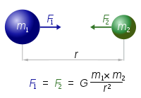

**Where F = force , G = gravitational constant = 6.67 x 10-11Nm2/kg2**

**\*\*\*\*\*\*Solved questions\*\*\*\*\*\*\*\***

**Relationship between g and G**

**G = Gravitational constant g = acceleration due to gravity**

**F = Gm1m2/r2  .............1**

**F = mg ..................2**

**g = Gm/ r2**

**Gravitational potential (V)**

**The gravitational potential at any point in a gravitational field is defined as the work done in taking a unit mass from infinity to that point. Its unit is Joules per kilogramme**

**V = (-)Gm/r**

**A body will tend to move from points of higher gravitational potential to points of lower gravitational potential**

**Kepler’s Laws of Planetary Motion.**

Planets are large natural bodies rotating around a star in definite orbits. The planetary system of the star sun called solar system consists of nine planets, viz., Mercury, Venus, Earth, Mars, Jupiter, Saturn, Uranus, Neptune and Pluto. Three empirical laws which govern the motion of these planets and are known as *Kepler’s laws of planetary motion*. These are,

1. **The law of Orbits** : Every planet moves around the sun in an elliptical orbit with sun at one of the foci.
2. **The law of Area** : The line joining the sun to the planet sweeps out equal areas in equal interval of time. *i.e.* areal velocity is constant.
3. **The law of periods** : The square of period of revolution  of any planet around sun is directly proportional to the cube of the semi-major axis of the orbit.

**Escape Velocity**

**This is the minimum velocity required for an object to just escape from the gravitational influence of the earth.**

**K.E = work done**

**mv2/2 = F x r**

**mv2/2 = Gmem/r2  x r**

**v = =**

Satellites are natural or artificial bodies describing orbit around a planet under its gravitational attraction. Condition for establishment of artificial satellite is that the centre of orbit of satellite must coincide with centre of earth or satellite must move around great circle of earth.

**Natural Satellite**: is an orbiting body that occurs naturally in space, while an artificial satellite are man made

**Orbital velocity** of a satellite is the velocity required to put the satellite into its orbit around the earth.

**Geostationary Orbits**

A satellite is said to be in a geostationary orbits ( also known as parking orbit) if it appears stationary to an observer on Earth’s surface.

Conditions for a satellite to be geostationary are

1. The satellite revolves in the same direction as the Earth (West to East)
2. The satellite’s orbital period is the same as the Earth’s rotational period
3. The satellite moves directly above the Earth’s equator

**\*\*\*\*\* solved question \*\*\*\*\*\***

**WEEK 3: Electric Field**

**Electric field can be defined any region or space where a charge experiences electric force.**

**Electric lines are imaginary lines whose direction at any point in the electric field is the same as the direction a small positive charge will follow if placed at that point in the electric field.**

**Properties Of Line Of Force**

1. **Two lines of force never intersect each other**
2. **The tangent to the curve at any point gives the direction of the electric intensity at that point**
3. **Lines of force start only from the positive charges and end only on the negative charges**
4. **In a uniform field, the lines of force are straight, parallel and uniformly spaced**





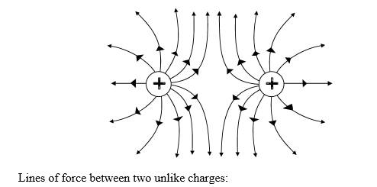

**COULOMB’S LAW**

States that the electrostatic force of attraction between point charges is directly proportional to the product of the charges and inversely proportional to the square of the distance between them i.e



The value for Coulomb’s constant is:

K = 

**ELECTRIC FIELD STRENGTH/INTENSITY**



The field intensity is a measure of the strength of an electric field. It is represented by the symbol ***E***.

 =

The unit for the field intensity is a  or N/C.

**ELECRIC POTENTIAL**

Electric potential V at a point in an electric field is the work done W in bringing a unit positive charge from infinity to that point

V= =

**V = E x r ( r = distance, E = electric intensity)**

**E = kq/r2**

v = **kq/r2  x r**

**v = kq/r**

**v = kq/r**

**\*\*\*\* solved Examples \*\*\*\*\*\*\*\*\*\*\*\***

**CAPACITORS AND CAPACITANCE**

A capacitor is a device for storing charges and energy. Consists of two parallel two pieces of metal near each other, separated by an insulator or air

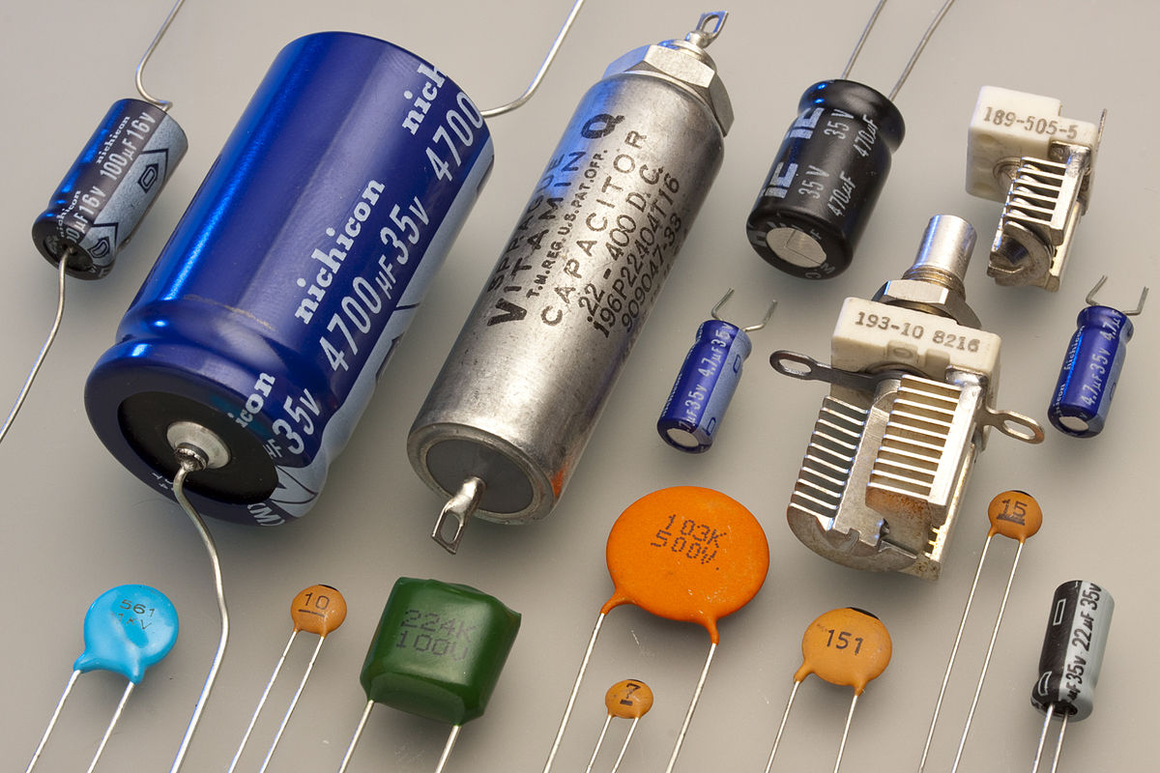

Assignment : types of capacitors

Symbol of a capacitor

Capacitor in Series

is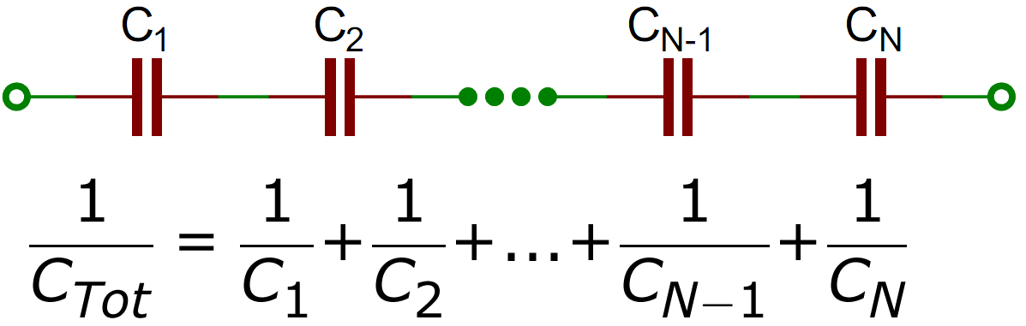

Capacitor in Parallel

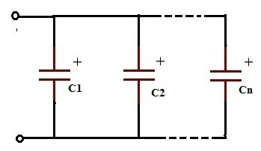

Capacitance

The capacitance of a capacitor is defined as the ratio of the electric charge to the potential difference across the plate of the capacitors. It is represented by C and its unit is Farad(F)

i.e 

**FACTORS THAT AFFECT CAPACITANCE OF A CAPACITOR**

1. Capacitance is directly proportional to the area C α A
2. Capacitance is inversely proportional to the distance between the plates C α 1/d
3. Capacitance is directly proportional to the dielectric constant C α ε

C = A ε/d where C = capacitance, A = area of plate, ε = permittivity of medium, d = distance between plates

**ENERGY STORED IN A CAPACITOR**

Work done = Average p.d X charge



******* solved question *********************

**Uses of capacitors**

* In radio circuits for tuning
* Ignition system of motor vehicles
* The elimination of spark when a circuit containing inductance is suddenly opened (induction coil)
* Used to control current in AC
* Used to separate D.C current from A.C current

**WEEK 4: CURRENT ELECTRICITY**

**Cell.**

* The device which converts chemical energy into electrical energy is known as electric cell.

*A*

–

+

Cathode

Anode

+

–

**+**

Electrolyte

**–**

(1) A cell neither creates nor destroys charge but maintains the flow of charge present at various parts of the circuit by supplying energy needed for their organized motion.

(2) Cell is a source of constant emf but not constant current.

(3) Mainly cells are of two types :

(i) Primary cell : Cannot be recharged, affected by defects like local action and polarization, have high internal resistance and hence give small current with a high drop of terminal p.d e.g Daniel cell, simple cell, Leclanche cell (wet and dry)

(ii) Secondary cell : Can be recharged , not affected by defects like local action and polarization, they have very low internal resistance, hence can give large current with a little drop of terminal p.d e.g lead-acid accumulator, alkaline cell

(4) The direction of flow of current inside the cell is from negative to positive electrode while outside the cell is form positive to negative electrode.

(5) A cell is said to be ideal, if it has zero internal resistance.

**PRIMARY CELL**

**Simple cell/ Voltaic cell:** consist of a glass vessel containing dilute tetraoxosulphate (VI) acid {the electrolyte}, two electrode: copper (positive electrode- anode) and zinc (negative electrode - cathode)

When the electrode are joined by a wire, chemical reactions take place. Zinc dissolves in the acid, while hydrogen bubbles are formed at the copper plate. Electrons flow from zinc plate to the copper plate.

The disadvantage of a simple cell is that can only supply current for a short period

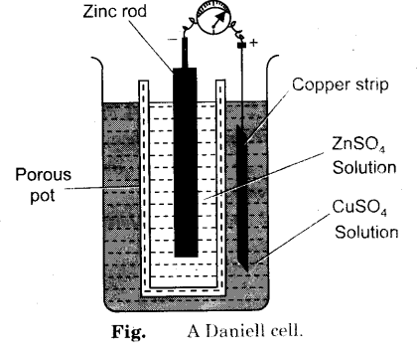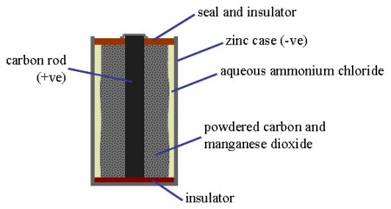

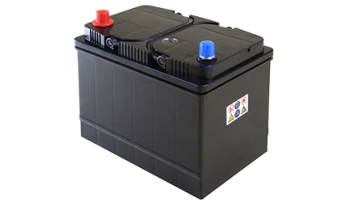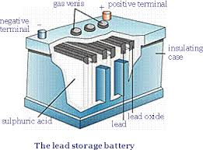

**Defects of Simple cell**

**Local Action :** When impure zinc plates are used in cell, the zinc plate continue to dissolve even when not supplying current, the impurities exist on the surface of the zinc which when in contact with acid forms minute cells on the zinc rod.

Local action can be prevented by amalgamating the surface of zinc plate ( rubbing with mercury)

**Polarisation:** formation of hydrogen bubbles at the copper plate, leads to accumulation of hydrogen bubbles around the copper plate act as a barrier that increases the internal resistance of the cell which will result in a decrease output current and a decreased emf

|  |  |  |  |  |
| --- | --- | --- | --- | --- |
| Cell | Positive terminal | Negative terminal | Electrolyte | Depolariser |
| Simple | Copper plate | Zinc plate | Dil. Sulfuric acid | - |
| Daniel | Copper container | Zinc rod | Dil. Sulfuric acid | Copper sulfate solution |
| Leclanche (wet) | Carbon rod | Zinc rod | Ammonium chloride paste | Manganese dioxide |
| Leclanche (dry) | Carbon rod | Zinc rod | Ammonium chloride paste | Manganese dioxide |
| Lead-acid accumulator | Lead oxide | Lead | Dil. Sulfuric acid | - |
| Nickel-Iron accumulator (Alkaline accumulator) | Iron | Cadmium | Dil. Sulfuric acid | - |

ASSIGNMENT

1. The value of e.m.f of a voltaic cell, which has dil. Tetraoxosulphate (VI) as its electrolyte, copper and zinc as its electrodes become less with use. Explain this observation and state how it can be corrected
2. State two advantages of a lead-acid accumulator over a Leclanche cell
3. Explain the following observation
4. A Leclanche cell which has given a heavy current for a short period will show loss of voltage
5. The cell in (a) above can be restored to full voltage by allowing it to rest for some hours
6. The zinc cup or rod in a leclanche cell is found to be deeply corroded after long use

WEEK 5:

**Electrolysis/Electrical Conduction Through Liquids and gases**

Electrolysis: Is the chemical change in a liquid due to the flow of electric current. The device used to study conduction of electric current through liquid is called a voltameter.

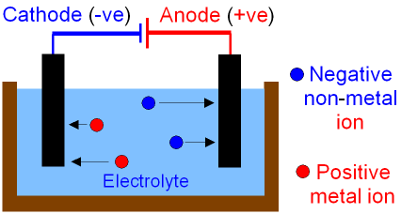

Electrolytes Are liquid that are good conductor of electricity eg acids, bases and salts.

Non-electrolytes are liquid that are poor conductor of electricity eg distilled water, sugar solution, paraffin, alcohol and oil.

Electrodes are conductors in the form of rods or plates immersed in the electrolyte. The positive electrode (Anode) is where current enters electrolyte while current leaves the electrolyte at the negative terminal (Cathode). In electrolysis the positive ions are attracted to the cathode while the negative ions are attracted to the anode. Liquids that are good electrolytes contain many free ions

**Faraday’s Laws of Electrolysis**

**Faraday’s First Law:** States that the mass of a substance, M, of a substance liberated during electrolysis is directly proportional to the quantity of electricity that has passed through the electrolyte.

Therefore:

M      =        Mass of a substance

Q       =        Quantity of electricity

M      =        ZIt

Q = It

Where z constant of proportionality which is the electrochemical equivalence

**Faraday’s Second Law:** States that the masses of the different substance deposited or liberated by the same quantity of electricity are inversely proportional to the equivalent of the substance.

No. of moles deposited α 1/charge on the ion

=

**Application of Electrolysis**

1. Electroplating: Is the process of coating metals with another metal in order to protect the metal from corrosion.
2. Purification of Metal: Electrolysis is important in purifying impure copper.
3. Extraction metals or electro-metallurgy: used to extract metals such as sodium or aluminum.
4. Calibration of ammeter.

***** solved questions on first and 2nd laws *******

**CONDUCTION OF ELECTRICITY THROUGH GASES**

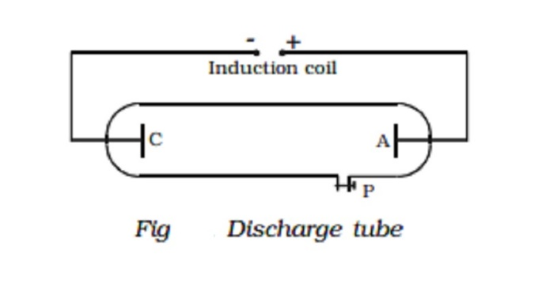

Gases at atmospheric pressure are not good conductors of electricity. To pass current through a gas, a discharge tube is used. The conduction of electricity through gases occurs at low pressure and high voltage. Under these conditions, the gas in the tube is ionized, the high voltage creates an electric field which accelerates the positive ions towards the cathode and negative ions and electrons towards the anode. The presence of electrons and ions promote conduction of electricity through gases.

**Application of conduction Through Gases**

1. In advertising industry/Neon Sign
2. In lighting/fluorescent tube
3. Identification of gases
4. Cathode ray oscilloscope/T.V tubes

**WEEK 6: ELECTRIC MEASUREMENT**

**Measuring Instruments.**

1. **Galvanometer:** It is an instrument used to detect small current passing through it by showing deflection. Galvanometers are of different types *e.g.* moving coil galvanometer, moving magnet galvanometer, hot wire galvanometer. The symbol is

***G***

1. **Ammeter:** It is a device used to measure current and is always connected in series with the ‘element’ through which current is to be measured. The reading of an ammeter is always lesser than actual current in the circuit. The smaller the resistance of an ammeter more accurate will be its reading. An ammeter is said to be ideal if its resistance *r* is zero.

**Conversion of galvanometer into ammeter**

A galvanometer may be converted into an ammeter by connecting a low resistance (called shunt *S*) in parallel to the galvanometer *G*

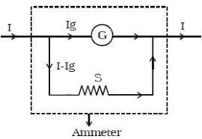

1. **Voltmeter:** It is a device used to measure potential difference and is always put in parallel with the ‘circuit element’ across which potential difference is to be measured. The reading of a voltmeter is always lesser than true value. The greater the resistance of voltmeter, more accurate will be its reading. A voltmeter is said to be ideal if it draws no current from the circuit element for its operation.

**Conversion of galvanometer into voltmeter :**

A galvanometer may be converted into a voltmeter by connecting a large resistance *R(multiplier)* in series with the galvanometer

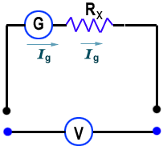

1. **Wheatstone bridge :** Wheatstone bridge is an arrangement of four resistors which can be used to measure one of them in terms of rest.

*P*

*Q*

*R*

*S*

+

–

*A*

*B*

*C*

*D*

***G***

*K*1

*K*2

The bridge is said to be balanced when deflection in galvanometer is zero *i.e.* no current flows through the galvanometer or in other words *VB* = *VD*. In the balanced condition, on mutually changing the position of cell and galvanometer this condition will not change.

1. **Meter bridge:** In case of meter bridge, the resistance wire *AC* is 100 *cm* long. Varying the position of tapping point *B*, bridge is balanced. If in balanced position of bridge *AB* = *l*, *BC* (100 – *l*) so that . Also  ⇒ 

*R*.*B*.

***G***

*R*

*S*

*P*

*Q*

*l cm*

(100 – *l*) *cm*

*E*

*K*

*A*

*B*

*C*

1. **Potentiometer :** Potentiometer is a device mainly used to measure emf of a given cell and to compare emf’s of cells. It is also used to measure internal resistance of a given cell.

=

*A*

*R*h

*K*

*B*

*e*, *r*

Primary circuit

Secondary circuit

*J*

*E*

***G***

**Difference between voltmeter and potentiometer**

|  |  |
| --- | --- |
| Voltmeter | Potentiometer |
| It draws some current from source of emf | It does not draw any current from the source of known emf |
| The potential difference measured by it is lesser than the actual potential difference | The potential difference measured by it is equal to actual potential difference |
| Its sensitivity is low | Its sensitivity is high |
| It is based on deflection method | It is based on zero deflection method |

**************SOLVED EXAMPLES******************

WEEK 7: MAGNETIC FIELD

Any substance that attracts objects toward itself is called a magnet.

**Properties Of Magnet**:

(i) A freely suspended magnet always aligns itself into north-south direction. The north pole of the magnet is pointing towards the North pole of the earth.

(ii) Like magnetic poles repel and unlike magnetic poles attract each other.

(iii) If a magnet is broken into small pieces, each piece will have both a North and South pole.

(iv) It has the ability to attract magnetic materials e.g steel, iron, nickel.

**TEMPORARY MAGNETS**  
These are magnets that lose their magnetic properties easily e. iron. Temporary magnets are used in the following devices: Electric bells, induction coil, telephone earpiece and magnetic relay.

**PERMANENT MAGNETS**These are magnets that do not lose their magnetism easily eg steel. Permanent magnets are employed in the following devices: electric motor, D.C Dynamo and Radio loudspeaker.

**Magnetic Induction**:

Is the process by which magnetic materials (e.g iron) become magnetized when they are near or in contact with a permanent magnet. Inducing magnetism produces a weak/temporary magnet. The side of the material facing the magnet will become the opposite pole as the magnet.

•**Ferrous material**: magnetic – anything which contains iron, nickel, or cobalt can be magnetised

•**Non**-**ferrous material**: non-magnetic e.g. copper, wood, etc.

**Magnetic domains**: A group of atomic magnets pointing in the same direction is called a magnetic domain. In a permanent magnet, all the magnetic domains point in the same direction.

Storage of magnets using soft iron Keepers: is a paramagnetic bar made from soft iron or steel, which is placed across the poles of a permanent magnet to help preserve the strength of the magnet by completing the magnetic circuit.

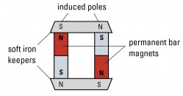

**MAGNETIZATION METHODS**:

1. **Stroking or Touch Method**: It can be magnetized strongly by **stroking** with one end of a magnet, in one direction. It can be single or double touch approach.

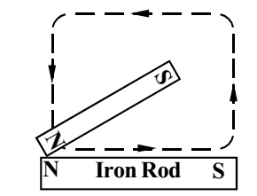

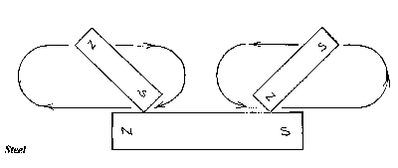

1. **Electrical Method Using Direct Current**: the most effective method is to place the metal in a long coil of wire (**solenoid**) and pass a large DC (**direct current**) through the coil.

**DEMAGNETIZATION METHODS**:

1. Smash it with a hammer, dropping etc.

2. Heating to a high temperature: the atoms vibrate vigorously when heated causing the magnetic domains to lose their alignment.

3. Solenoid method but with alternating current

>>>> Differences between temporary and permanent magnet//magnetic properties of iron and steel

>>>> Soft magnetic materials and hard magnetic materials

**Earth’s Magnetism**

Earth is or behaves like a huge magnet.

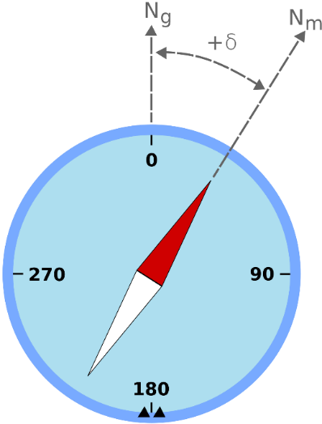

(i) Magnetic Declination (θ) The smaller angle subtended between the magnetic meridian and geographic meridian is called magnetic declination.

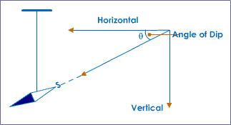

(ii) Magnetic Inclination or Magnetic Dip (δ) The smaller angle subtended between the magnetic axis and horizontal is called magnetic inclination on magnetic dip.

**Magnetic Field**

The region around a magnet where magnetic effects can be detected is called a magnetic field.

**PROPERTIES OF MAGNETIC FIELD (LINES)**

1. They point from the north pole to south pole.
2. They never intersect with one another.
3. They are in a state of tension which causes them to tend to shorten themselves.
4. The higher the density of the lines in a region, the greater the magnetic field strength at that point.

**MAGNETIC LINES OF FORCE**

These are lines along which a free north pole will tend to move.

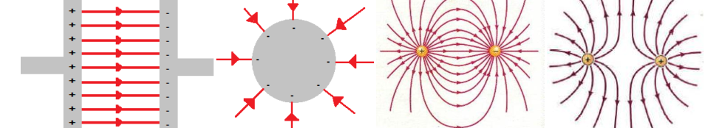

**MAGNETIC FLUX**

This refers to the number of magnetic lines of force in a given magnetic field. It is a vector quantity and the unit is Weber (Wb).

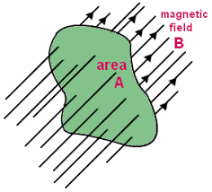

**MAGNETIC FLUX DENSITY**

This is defined as the magnetic flux per unit area in a given magnetic field. It is denoted by **B** with its unit Wb/m2 or Telsa(T)

**B = Magnetic flux/Area =**

The magnetic force experience is directly proportional to sin θ which is directly proportional to the induced current **I** , length **L** and directly proportional to the magnetic flux density **B** i.e

F α sin θ

F α I

F α **B**

F α L **(length)**

F α sin θ α I α **B** α L

sin θ = 1 when θ = 90°

F = KBIL sin θ (k = 1)

F = BIL

The magnetic effects of electric current was discovered by Oersted. He discovered that around a wire carrying a current, there is a magnetic field. He concluded

1. A current has a magnet field all round it.
2. The magnetic field is in a direction perpendicular to the current ie 90°.

MAGNETIC FIELD AROUND CURRENT CARRYING CONDUCTORS

1. FIELD DUE TO A STRAIGHT WIRE

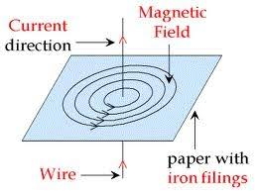

The field pattern around a straight wire consist of circles with the wire as the centre and the field is symmetrical. If the direction of the current, the direction of the field can be predicted by MAXWELL CORK SCREW RULE OR RIGHT- HAND CORK SCREW RULE

MAXWELL CORK SCREW RULE: states that if a right-handed screw moves forward in the direction of the current, the rotation of the screw gives the direction of the field.

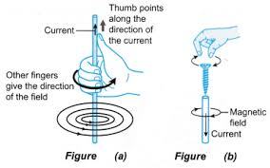

1. FIELD DUE TO A CIRCULAR COIL

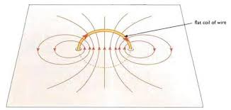

1. FIELD DUE TO A SOLENOID

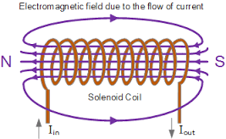

A solenoid is a long cylindrical coil. It produces a field similar to that of a bar magnet.

**Fleming’s Right Hand Rule:**

It states that when the first three fingers of the right hand are held at the right angles to each other with the forefinger pointing in the direction of magnetic field and the thumb in the direction of motion, the second finger will point in the direction of the induced current.

**APPLICATION: ELECTROMAGNET**

An electromagnet is obtained by winding an insulated wire round a soft iron rod with the ends connected to a D.C source. The magnetic properties disappears when the current supply is cut off.

**STRENGTH OF ELECTROMAGNET**

1. Increase as the current increases.
2. Increases as the number of turns of the coil increases.

**APPLICATION OF ELECTROMAGNETISM**

1. Telephone earpiece /// note
2. Electric bell //

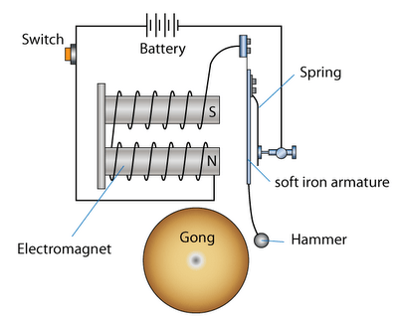

* When the ‘push’ switch is depressed, the circuit is closed. Current passes through the electromagnet windings and the core becomes magnetised.
* The magnetised core attracts the iron armature which makes the striker hits the gong.
* However, the movement of the armature opens the ‘make and break’ switch which switches the electromagnet off. The iron armature springs back to its original position, closing the ‘make and break’ switch and start the cycle again.

WEEK 9: **ELECTROMAGNETIC FIELD**

A changing electric field is accompanied by a magnetic field and a changing magnetic field is accompanied by an electric field. The joint interaction of electric and magnetic forces give rise to an electromagnetic field.

A current carrying conductor placed in a magnetic field experience a force. The force is always directed perpendicular to the direction of the current and the magnetic field

**Fleming’s Left Hand Rule:**

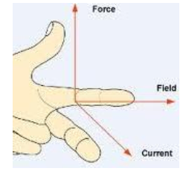 

If we stretch the thumb, the forefinger and the central finger if left hand in such a way that all three are perpendicular to each other, then if forefinger represents the direction of magnetic field, central finger represents the direction of current flowing through the conductor, then thumb will represent the direction of magnetic force.

DC MOTOR

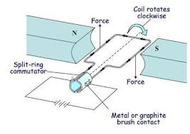

A DC motor is an electrical machine devised to convert electrical energy into mechanical energy.

The basic component of a DC motor is a current carrying armature which is connected to the supply end through the commutator segment and brushes. The armature is placed between two permanent magnets which produce a magnetic field.

The applied direct current converts the electrical energy into the mechanical energy because of the interaction of two magnetic fields. One field is produced by the permanent magnet and the other is produced by the electric current flowing through the armature winding. Because of the interaction of these two fields, the armature experiences a force which tends to rotate the rotor.

// difference between Fleming’s Right and Left hand rule

Fleming's left hand rule is used in motors to determine the direction of rotation of the conductor when we know the direction of the magnetic field and the direction of current through the conductors.

Fleming's right hand rule is used in generators to determine the direction of induced current in the conductor when we know the direction of the magnetic field and the direction of rotation of the conductor.

>>> Ampere’s Law

APPLICATION OF ELECTROMAGNETIC FIELD

1. **Electric Motor**

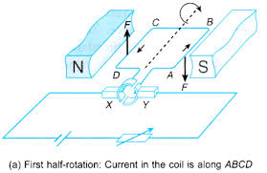

It is a device which converts electrical energy into mechanical energy.

As current passes around the loop of wire, one side of it will experience a force pushing it upwards.

The other side will feel a force pushing it downwards, so the loop will rotate. Because of the split ring, when the loop is vertical, the connections to the supply through brushes swap over, so that the current flowing through each side of the loop changes direction. The wire at the bottom is now pushed upwards and the wire at the top is pushed downwards – so the loop carries on turning. The arrangement of brushes and split ring changes the direction of the current flowing through the loop every half turn, which means the rotation can be continuous. Increasing the rate at which the motor turns can be done by:

1. Increasing the strength of the magnetic field using a stronger magnet.
2. Increasing the number of loops
3. Increasing the current.
4. Place a soft-iron core inside the coil.

**ELECTROMAGNETIC INDUCTION**

This is a phenomenon in which electricity could be produced using magnet or magnetic field.

The relative movement between the solenoid and the magnet induces an emf in the circuit. The magnitude of the induced emf depends on

1. The number of turns in the solenoid.
2. The strength of the magnet.
3. The speed with which the magnet moved into or withdrawn from the solenoid.

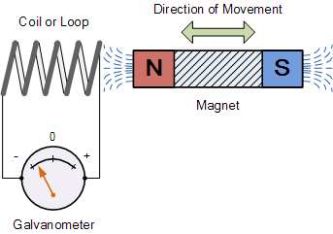

**LAWS ELECTROMAGNETIC INDUCTION**

1. **Faraday’s law**: States that the induced emf in a circuit is directly proportional to the rate of change of magnetic flux linking the coil.
2. **Lenz’s law**: States that the induced current flows in such a direction as to oppose the change producing it.( This law help to identify direction of an induced current.)

**Eddy Current**: The induced current which tends to stop/oppose the motion of the coil in a magnetic field.

**FACTORS THAT AFFECT MAGNITUDE OF INDUCED EMF/CURRENT**

1. The strength of the magnet.
2. The number of turn of coil.
3. Speed of the magnet.

**APPLICATION OF ELECTROMGNETIC INDUCTION**

1. Dynamo
2. Transformer
3. Induction coil

**INDUCTION COIL**

It is a device used to induced a large emf sufficient to produce a spark between two terminals or a device for producing high voltages.

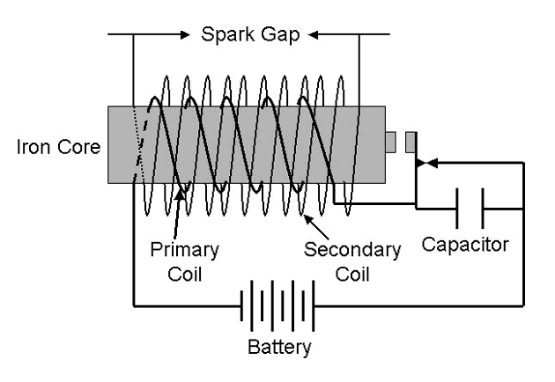

**Uses Of An Induction Coil**

1. To produce high voltage from low voltage.
2. For studying the discharging of electricity through gases.
3. To produce sparks required to ignite the petrol-air mixture in a car cylinder.
4. For x-ray tubes to produce the voltage required.

**TRANSFORMER**

This is a device that changes a high alternating voltage at low current to a low alternating voltage at high current or vice versa.

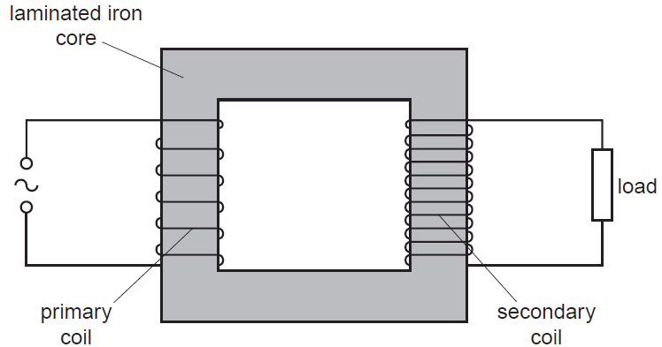

**Working Principle**: if the primary coil is connected to an a.c source, there will be magnetic flux in the core which will varies periodically and thereby produce an induced emf in the secondary coil. The magnitude of the induced emf is a function of the p.d across the terminals of the primary coil and the relative number of turns in the coils.

A step-up transformer is one where the emf in the secondary coil is greater than the emf

Ns/Np = Vs/Vp

Ns and Np = number of turns in secondary and pry respectively.

Vs and Vp = secondary and pry output voltage.

POWER TRANSFER IN A TRANSFORMER.

For ideal transformer, the power supplied to the pry coil is fully transferred to the secondary coil,

Power in pry coil = Secondary power in secondary coil.

IPVP = ISVS

IP, IS  =

|  |  |
| --- | --- |
| Energy Loss | Energy Minization Processes |
| Energy or heat losses in the coil | Use low-resistance coil eg insulated coils |
| Eddy current losses(copper losses) | Laminate core |
| Flux leakage | Efficient core design |
| Hysteresis losses | Core made of soft-iron or soft-magnetic materials |